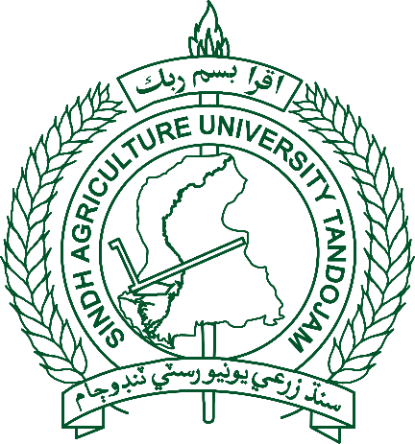

Admission Policy 2025-26

2 Years Diploma

Livestock Assistant & Agriculture Field Assistant (Evening Program)

offered by

Sindh Agriculture University Campus, Umerkot

|  |
| --- |
| ADMISSION POLICY 2024-25  2 YEARS DIPLOMA OF LIVESTOCK ASSISTANT & AGRICULTURE FIELD ASSISTANT (EVENING PROGRAM) |

|  |
| --- |
| GENERAL INSTRUCTIONS |
| 1. Admission to the first year of the 02 Years Diploma of Livestock Assistant and Agriculture Field Assistant Course are made according to the policy and the rules framed by the university. The rules of admission described below are subject to modification by the statutory bodies of the university as and when considered necessary. 2. In case a candidate provides incorrect information and/or false certificates/documents detected before or at any stage after admission, his/her admission shall be canceled. 3. A candidate suffering from any life-threatening contagious disease is not eligible for admission. If detected at any stage, his/her admission shall be canceled. 4. An applicant registered with any other University / Institution / College, if selected at SAU Campus Umerkot shall be admitted only after his / her cancellation of registration / admission to another academic institution. Any proof of dual admission shall result in cancellation of admission at SAU Campus Umerkot. 5. An applicant previously admitted at any other University / Institution but rusticated/debarred before applying for admission at SAU Campus Umerkot shall not be considered for admission at this university. 6. An applicant convicted of moral turpitude shall not be considered for admission. 7. The hostel accommodation is not the liability of the campus and should only be provided subject to the availability of space. |

|  |
| --- |
| REGULATIONS FOR ADMISSION TO (02) YEARS DIPLOMA |
| The following regulations shall apply to candidates seeking admission to 02 Years (4 Semesters) Diploma of Livestock Assistant & Agriculture Field Assistant Course (Evening Program). |
| ELIGIBILITY |
| 1. Minimum requirement for admission shall be Matriculation Science or Equivalent Examinations with at least 50% marks. 2. Admission of candidates having domicile of any province of Pakistan shall be made according to number of seats described against each program, once seats being fully offered and no seat remains vacant the selection of candidate will be made / determined by Admission Committee as per preferable choice & merit based on SSc-II, which shall be treated as final. 3. The total number of seats are as below: -  |  |  |  | | --- | --- | --- | | **Sr. No.** | **Name of Diploma/Course** | **Seats** | |  | **Livestock Assistant** | **60** | |  | **Agriculture Field Assistant Course** | **60** |  1. If marks are equal between two or more candidates, selection will be made based on marks obtained in science subjects of Matriculation Examinations related to the program. 2. All the candidates must produce marks certificates of S.S.C/ Domicile/PRC and other required documents in original at the time of admission/registration which will be returned after necessary verification. 3. After verification of the documents, in case of any forgery/manipulation detected at any stage, the university authorities shall have the right to cancel his/her admission/degree. 4. All the interested candidates who wish to get admission to 02 years Diploma Courses for the academic year 2025-26 click the given link (<https://sau.edu.pk/undergraduate/>). The candidates shall have to pay Rs. 2500/- (non-refundable) as registration / processing fee through challan in any branch of HBL or by Mobile Banking Application in relevant account (00427991859203). The candidate shall be required to send the printed copy of the admission form along with four (04) recent passport-size photographs & paid bank challan of prescribed/required fees through surface mail up to closing date to the Director Admissions (Undergraduate Programs), Sindh Agriculture University Tandojam. |

**BREAKUP OF VARIOUS FEES (Rupees)**

**Fee to be charged from the students registering in 2 Years Diploma of Livestock Assistant & Agriculture Field Assistant Course 2024-25 (Evening Program)**

|  |  |  |  |
| --- | --- | --- | --- |
| S.# | FEES STRUCTURE | 2025-26 | |
| **SAU CAMPUS, UMERKOT** | |
| **At the time of 1st admission** | **Subsequent Semester** |
| 1 | Admission Fee (Once) | 2000.00 | 0.00 |
| 2 | Registration Fee (Per Semester) | 3050.00 | 2000.00 |
| 3 | Tuition Fee (Per Semester) | 3000.00 | 2520.00 |
| 4 | Enrolment Card Fee (Once) | 770.00 | 0.00 |
| 5 | Identity Card Fee (Per Semester) | 330.00 | 330.00 |
| 6 | Examination Fee (Per Semester) | 1430.00 | 1430.00 |
| 7 | Transport Charges (Per Semester | 2420.00 | 2420.00 |
| Total | | **13000.00** | **8700.00** |