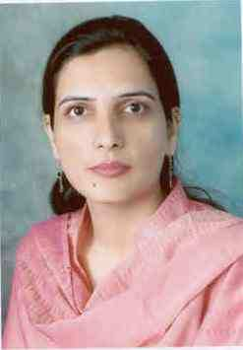
Dr. NAHEED AKHTER TALPUR
Associate Professor [BPS – 20] PhD. (Soil Science)
University of Bonn, Bonn, GERMANY
Associate In charge, ‘Plant Nutrition Lab.’ & ‘Organic Fertilizer Lab.’
Department of Soil Science, Faculty of Crop Production
Sindh Agriculture University, Tandojam-70060, Sindh, Pakistan
[http://fcpd.sau.edu.pk/ss/faculty-members.php]
https://pk.linkedin.com/in/naheed-akhter-25842684
https://www.zef.de/header/staff/display-profile.html
https://www.researchgate.net/profile/Naheed-Talpur

RESEARCH THEMES: Soil Fertility
Plant Nutrition
Soil Survey – GIS
Soil resource management through spatial variability mapping of soil
properties, best fertilizer management practices, Integrated plant
nutrition management using low-cost fertilizers & 4R nutrient stewardship. Receiving many trainings at National & International level: Such as “Capacity Building of Academic leadership in Teaching, Research & Services”; Three days training on “Monitoring and Mapping of Forest using satellite data for Clean and Green Pakistan” ; Hands on training on agricultural production systems Simulator APSIM Modeling workshop (DFAT-CSIRO INDUS Pakistan Project); “DAAD Alumni Summer School Coping with Disasters and Climate Extremes – Challenges & Cooperation Potential”; and “Advance training in Remote Sensing and GIS”; “International workshop on: Identifying sustainable agricultural technologies and translating research findings into information accessible to extension workers and farmers”; and “DAAD Alumni Summer School “Coping with Disasters and Climate Extremes – Challenges and Cooperation Potential”

POST-GRADUATE GUIDANCE: 19

PUBLICATIONS: 19

ADDITIONAL ASSIGNMENT: Member, Self-Review of MS/ME/M.Phil/Ph.D Programs for the year 2021-22
Head Invigilator, Faculty of Crop Production, SAU, Tandojam (Academic year 2020, Calendar year 2021)
Member, Quality Enhancement Cell, Department of Soil Science, SAU Tandojam
Member, Board of Advanced Studies, Department of Soil Science, SAU Tandojam
Member, Beautification Committee of Convocations, SAU Tandojam

