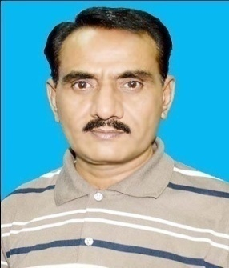
Name: Shoukat Ali Soomro
Designation: Assistant Professor
Department: Land and Water Management
Faculty: Agricultural Engineering
Cell Phone No. +92 300-802-2844
Email: sasoomro@sau.edu.pk

Experience: 07 Years as Assistant Professor (FAE) SAU Tandojam
03 Years as Lecturer (FAE) SAU Tandojam
10 Years as Water Management Supervisor, AE&WM, Sindh

Publications: 12 published in national and international Journals

Qualification: Ph. D. (Irrigation and Drainage), FAE (SAU) Tandojam
M. E. (Land and Water Management), FAE (SAU) Tandojam
B.E. (Agricultural Engineering), FAE (SAU) Tandojam
Membership: PEC Registration No. AGRI/2547.
Member of Program Team for Degree Program M.E. and Ph.D. (LWM) under Directorate of Quality Enhancement Cell, SAU Tandojam
Member of Board of Studies (LWM), (FAE), SAU Tandojam
Member of Vigilance and Counselling Committee (FAE), SAU Tandojam
Faculty Representative (FAE), SAU Tandojam
Factotum (FAE), SAU Tandojam
Achievements: Supervised 12 groups of undergraduate students
Produced 15 M.E. Students as main Supervisor and 5 students are working
Produced 23 M.E. Students as Co-Supervisor
Technical Assessment of 12 Synopsis of M.E. Students
Teaching to undergraduates and Postgraduates
Expertise: Irrigation Engineering
Drainage Engineering
Water Management
Land Management
Land Scaping

