Profile of Dr. Mashooque Ali Talpur
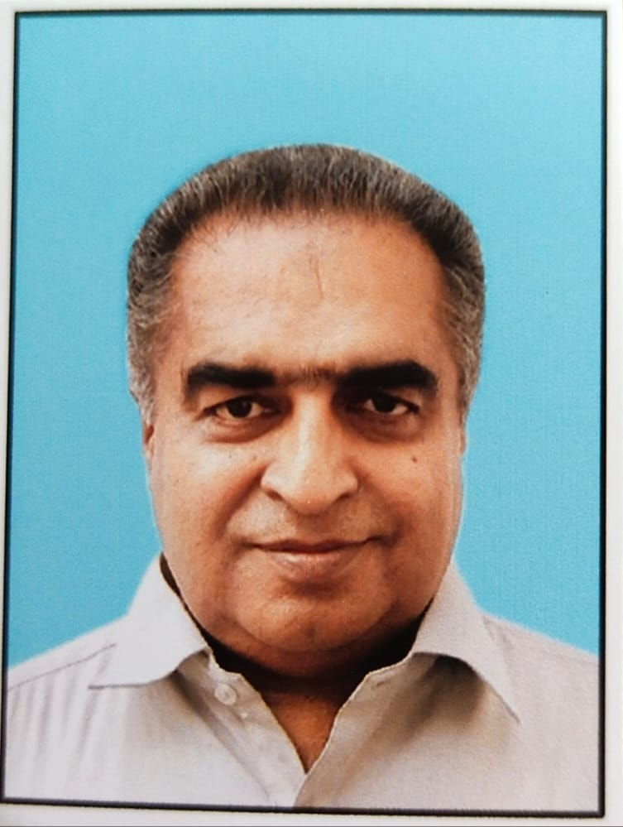
Associate Professor
Department of Irrigation and Drainage
Dr. Talpur is a Professional Engineer with more than twenty-three years working experience in the field of Water resources, Irrigation, Agriculture, Social and Environmental Studies. Recently working as Associate Professor in Sindh Agriculture University, Tandojam. In University, he is engaged in teaching and research at undergraduate as well as post graduate level studies. He is also involved in research projects at departmental level.

EDUCATION
PhD (Irrigation Engineering) | Nanjing Agricultural University, China
- PhD Scholarship from SAU Tandojam & Higher Education Commission Pakistan (under Mega Project)
M.E (Hydraulics and Irrigation) | Mehran University of Engineering and Technology, Jamshoro
- M.E scholarship from International Water Resources Management Institute (IWMI) for research only
M.A (Sociology) private | University of Sindh, Jamshoro
B.E. (Agri.) | Sindh Agriculture University, Tandojam
EXPERIENCE
He possesses more than 23 years’ experience in government department, consultancies, national and international research institutions as well as educational organizations like, currently working as Associate Professor in Sindh Agriculture University (SAU), Tandojam. Previously worked as Senior Irrigation Engineer in Techno-Consult International (TCI), worked as Deputy Director (Field) in Sindh On-Farm Water Management (SOFWM) department Government of Sindh, worked as Social Mobilizer cum Team leader for, Sindh Irrigation and Drainage Authority (SIDA) at Umarkot, Sindh, worked as research officer for, International Water Management Institute, (IWMI) at Hyderabad, Sindh, engaged as Program Officer (Trainings) for, Sindh Agriculture and Forestry Workers Coordinating Organization, (SAFWCO), earlier affiliated as Social Mobilizer for, SAFWCO, also worked as Junior Irrigation Engineer for, International Irrigation Management Institute (IWMI), at Mirpurkhas and also acquire research fellowship for Master Engineering from International Water Management Institute (IWMI) Pakistan.
Trainings and Seminars
He has successfully contributed as resource person in 05 trainings and attended more than 10 trainings and participated more than 05 seminars and workshops as well as national and international conferences in the field of irrigation engineering and management, drainage, hydraulics and water management.
Area of Interest
Water resources engineering and management, irrigation, agricultural drainage and hydraulics.
Publications
He is an author of 33 research papers in HEC recognized journals, 13 international (11 SCI with Impact Factor) and 17 national research papers and presented 02 papers in national and 01 paper in international conferences. Dr. Talpur is also an author of a book entitled, “Water Course and its importance” (published in local language, “Sindhi”). He is also an author of six research articles published in local newspaper and monthly magazines.
Supervision/co-supervision in thesis work /research mini projects
He has 06 Postgraduate students in PhD and 23 Masters of Engineering under his supervision and co-supervision out of which 03 PhD and 19 Master students have completed their degrees. Besides these, 05 groups in undergraduate studies have been supervised for mini projects in water related fields.
Membership
- Member of Pakistan Engineering Council
- Member Faculty Board of Studies FAE, SAU Tandojam
Reviewer in research Journals
He has been reviewer of three research journals and reviewed several research papers. He has also been engaged to evaluate different research projects submitted to HEC.
Computer Skills
- Microsoft Office (MS Office)
- Simulation of Irrigation Canal (SIC) System
- CROPWAT 8.0
- SPSS 16.0
Additional Assignments
- Chairman Department of Irrigation and Drainage, FAE, SAU Tandojam
- Chairman Departmental board of Study of Irrigation and Drainage, FAE, SAU Tandojam
- Head Invigilator of the Faculty of Agriculture Engineering
- Head of OBE team, Faculty of Agriculture Engineering.

