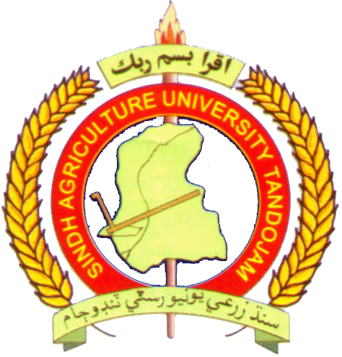
Registration No:

Faulty of Agricultural Engineering
Sindh Agriculture University Tandojam
MID SEMESTER / FINAL EXAMINATION 2022 OF 1st / 2nd SEMESTER YEAR
B.E. (Agricultural Engineering)
Course Title: Code:
Dated: Time Allowed: 30 / 120 Minutes Max. Marks: 20 / 60
NOTE: ATTEMPT ALL QUESTIONS: ( 3 questions for mid semester / 5 questions for final examination)

Q# | CONTENT | CLO | Taxonomy Level | Marks

