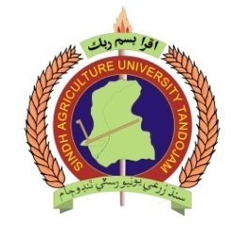
Form No. ___________________
(to be filled by Alumni Relations Manager)

Sindh Agriculture University Tandojam Alumni Network

ALUMNI REGISTRATION FORM

If you are an Alumnus (Graduate or Postgraduate) from Sindh Agriculture University Tandojam, you are invited to register as a member of the Alumni Network by filling the information given below:

Please tick one: Male Female Please tick one: Mr. Ms. Dr.
Name (in block letters)
Father’s Name
Last Name (Surname)
Nationality
Date of birth. | - - (DD/MM/YYYY)
CNIC No. | - -
Mailing Address | House No./Street :
 | City |  |  |  |  | Province/State
 | Post/Zip Code |  |  |  | Country
Designation/Occupation
Organization
Organization Address
Contact | Mob: Off: Res:
E-mail Address
Year of Admission
Year of Graduation
Degree(s) Obtained  (B.Sc/B.E/DVM/BSIT/  MSc/M.E/M.Phil/PhD) |  |  |  | Discipline: ___________________________

______________________  Date | ______________________  Signature
Note: Please mail/post filled-in information to Dr. Zaheeruddin Mirani (zamirani@sau.edu.pk), Manager University Advancement, Sindh Agriculture University Tandojam, Pakistan. For on-line registration, please visit SAU Website www.sau.edu.pk, click Alumni Corner and follow the instructions.

